GROUP PROJECT PROGRESS REPORT
Group Members
Ancila M Ulungi: M00517972
Mokshraj Gungah: M00504017
Ameer Ghaffori: M00430356
Tanweer Baig M00488231

HOME MONITORING SYSTEM
The idea behind the project that has been proposed is to create an app which will function as a controller to a Rasberry pi. The Rasberry pi will function as a server on which the hardware properties that are intended to be used will be connected and it will be linked with the app created and the app will be used to access the surveillance camera, temperature sensor and the door lock.
At the moment what has been done is the outline of the app itself. Since all that we need are three buttons to control the camera, door lock and temperature sensor so only three buttons have been created. And for each of the buttons a subActivity has been created to out in the functionality code for it. Apart from that some parameters will be add to the foreground of the app to make it more attractive. The following is a printscreen of how the app looks so far;
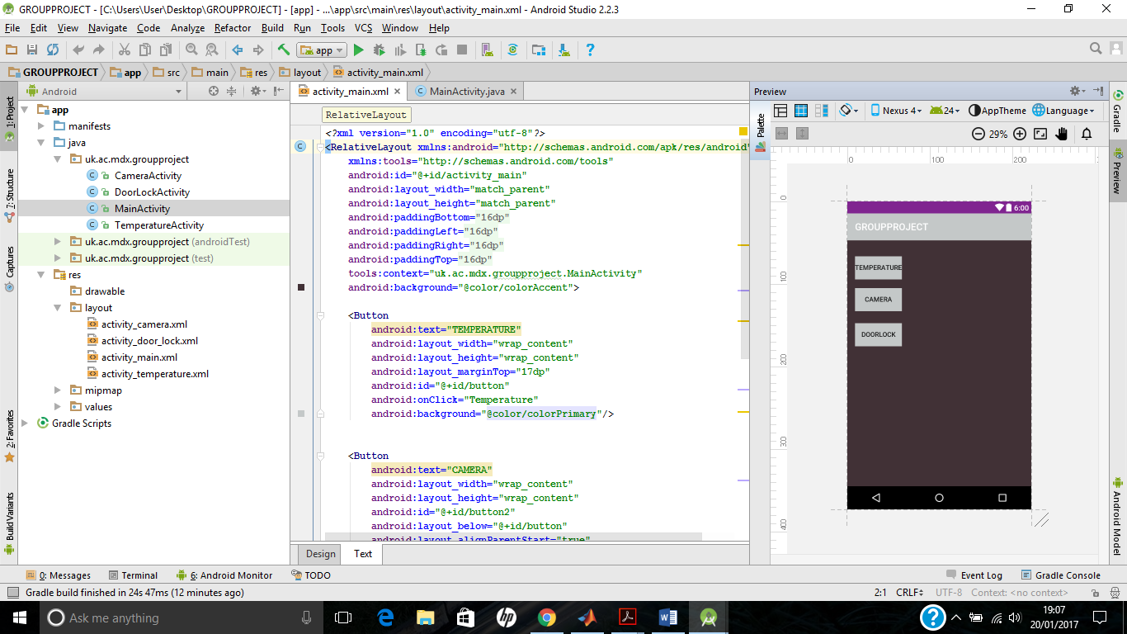
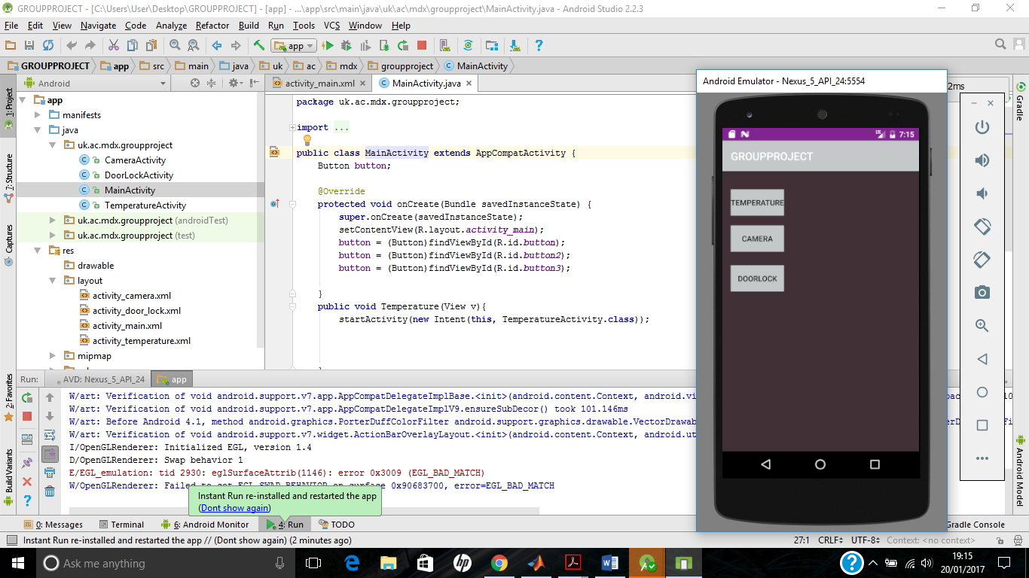

As seen from the above print screens that were taken from android studio. So what has been done so far is create the buttons, change the background theme of the app. For each of the buttons a sub-activity has been created so that onclick the app takes you to the second activity which is the activity for the button. In the second activities this is where the functionality codes for each of the hardware is written.
What left to be done for the app is add some designs or pictures on it to make it look more attractive. And also the back button need to be added so that once you are done with one of the buttons then you can come back and choose a different button.
Also a connection between the app and the Raspberry pi needs to be done then the hardware connection to the Raspberry pi and also connecting the Raspberry pi to a server since it will work as server for the functionalities.
In conclusion that is what that has been achieved so far.

